INTRODUCTION

Project overview:

Importing and securing data in a Service Now project involves loading data from various sources into Service Now and then ensuring its security. This process typically uses import sets, transform maps, and various security measures to protect sensitive information.

Purpose

Importing and securing data in a Service Now project aims to efficiently and safely load data into the platform, ensuring data integrity and protecting sensitive information. This involves using import sets to bring data from various sources into Service Now, mapping it to target tables, and implementing security measures to control access and prevent unauthorized modifications.

IDEATIONPHASE

Problem statement:

Linking each record to an employee and pulling some employee details (like department ) into the record for easier reporting

Challenges:

Import data needs to be accurate and consistent across different sources

Different systems of in have different data structures and formats

Objectives:

Using service now’s built in security features

Implementing data validation and cleansing

REQUIREMENT ANALYSIS

Solution requirement (functional & Non functional)

Team ID LTVIP2025TMID30683

Project Name importing & securing data in service now

**Functional Requirements:**

Following are the functional requirements of the proposed solution

**FR NO. Functional requirements. Sub requirements**

FR-1. Tables. Create table

FR-2. Importing data. Importing data

Map fields

FR-3. Using Dot walking to Dot walking

Access employee

Department information

FR-4. Access control list (ACL). Creating an ACL

FR-5. Roles. Creating role

Update elevate

Role

FR-6. Result. Testing results

**Non functional requirements**

Following are the non fiction requirements of the proposed solution

**NFR NO. Non. Functional Description**

**Requirements**

NFR-1. **Usability.** Answer the data

Import interface is

. User friendly

NFR-2. **Security.**  Define who can

Access modified or

Importing data

NFR-3**. Reliability**  Define how Data

Integrity will be main

Tained during import

NFR-4.  **Performance.**  Define acceptable

Response times for

Data import process

NFR-5.  **Availability.** Implement

Comprehensive

Logging

NFR-6. **Scalability.** And so the system can

Handle

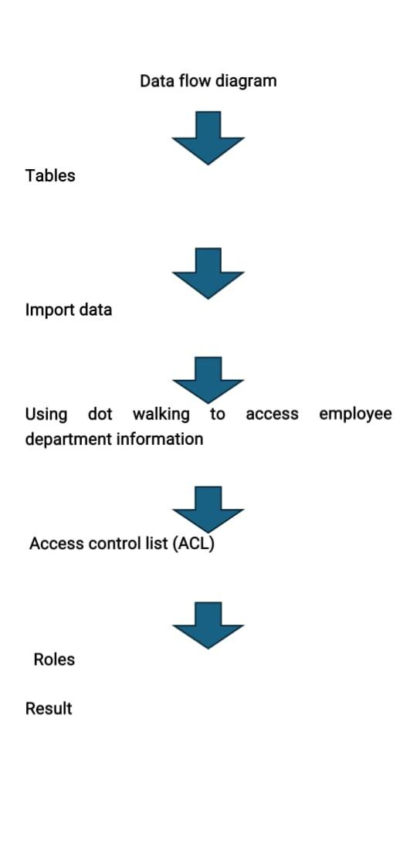

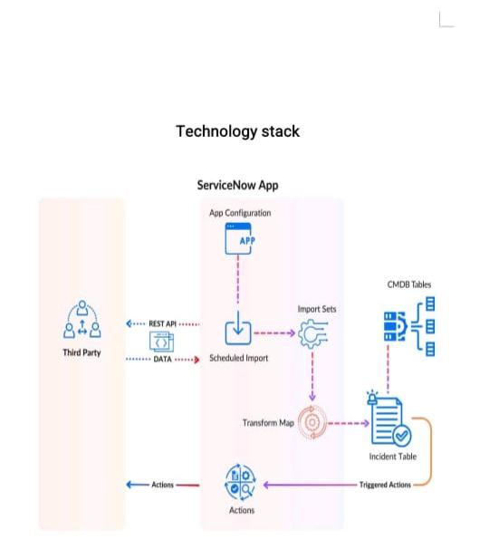

**Technology Stack: The image shows how data flows from a third-party system into the Service Now app, gets processed through import mechanisms, and ends up in the Incident Table, where it can trigger further actions or updates.**

**Third Party → REST API → Service Now**

**Data is sent from a third-party system via REST API.**

**REST API → Scheduled Import**

**API data is captured by a scheduled import job.**

**Scheduled Import → Import Sets**

**Data is loaded into temporary import tables.**

**Import Sets → Transform Map**

**Data is transformed to match the format of the target tables.**

**Transform Map → Incident Table**

**Transformed data is saved as incidents in Service Now.**

**Incident Table → Triggered Actions**

**Actions (like alerts, updates) are automatically triggered.**

**Incident Table ↔ CMDB Tables**

**Incidents are linked to Configuration Items (Cis) from the CMDB.**

**PROJECT DESIGN**

**Proposed solution template**

Project team shall fill the following information in the proposal solution template

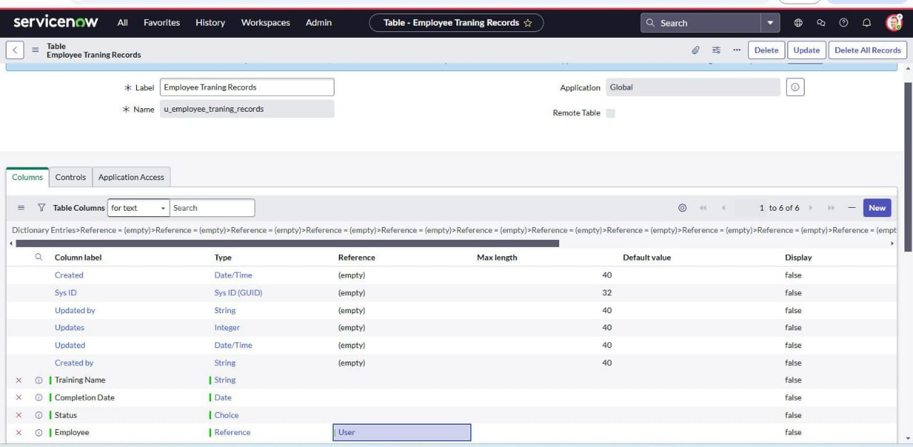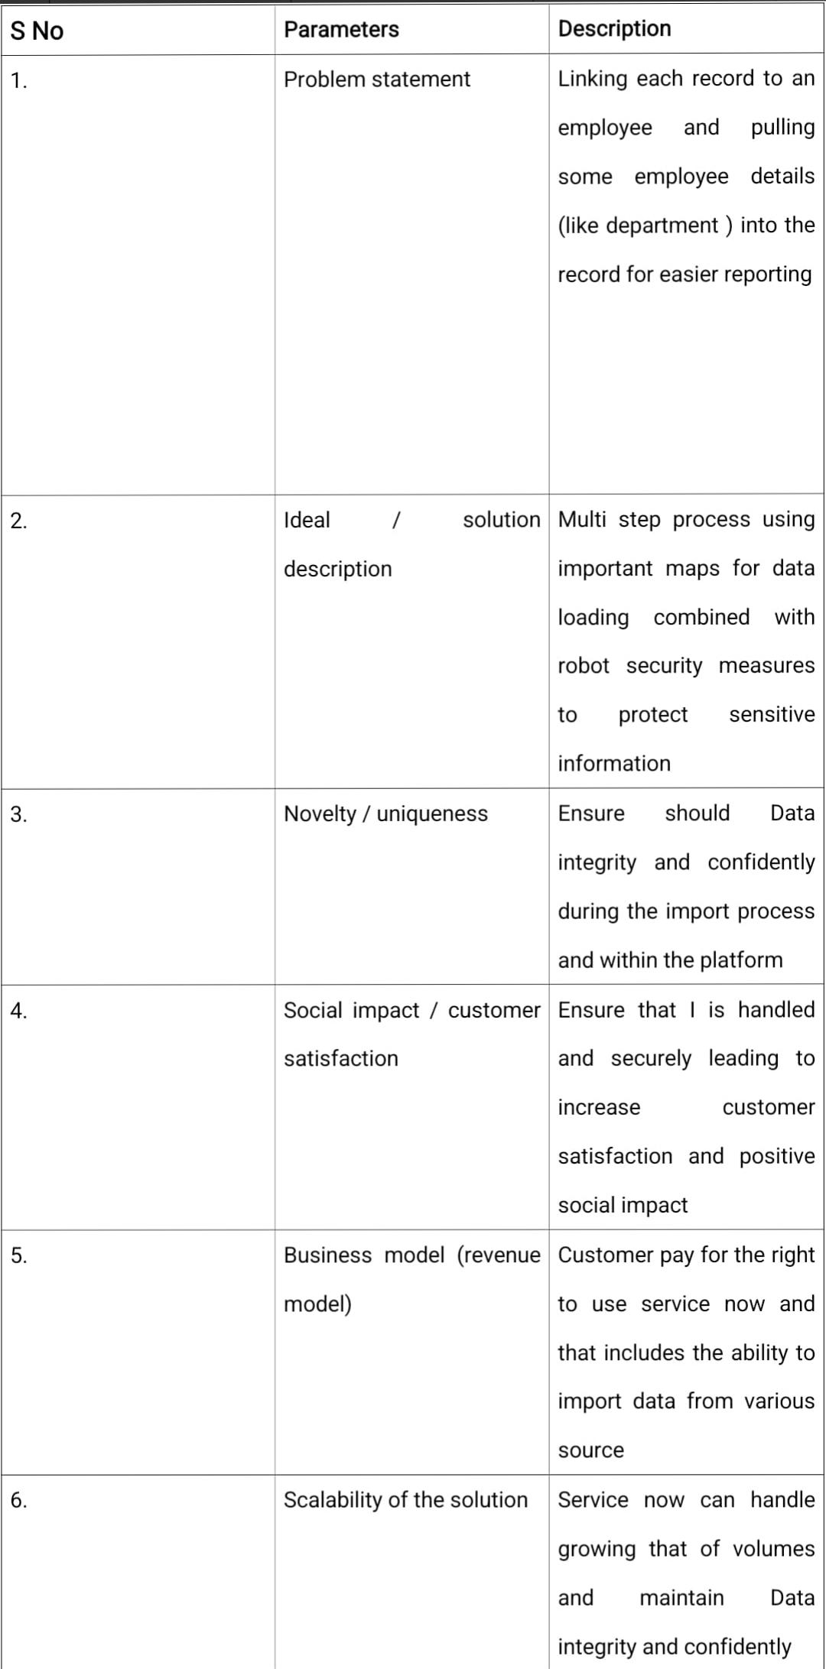

**Milestone 1: tables**

**Steps:**

**1.Open service now**

**2.Click on all > >search for tables**

**3.Select tables under system security**

**4.Click on new**

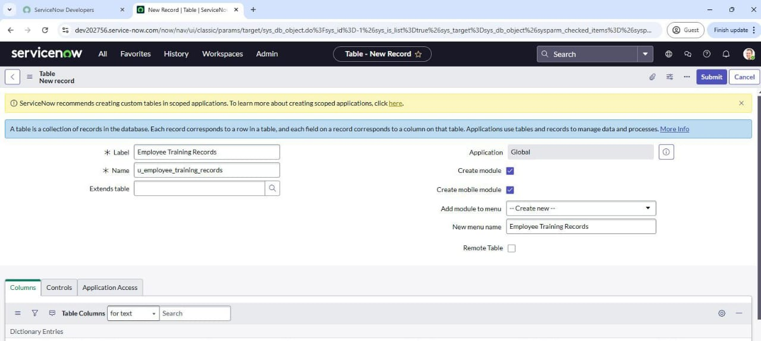**5.Fill the following details to create a new table**

**6.Add the following fields:**

**7.Training name (type: string)**

**8. Completion date (type: date)**

**9. Status (type : choice)**

**10. Employee ( type : reference),(reference field to system user table )**



**11.Click on submit**

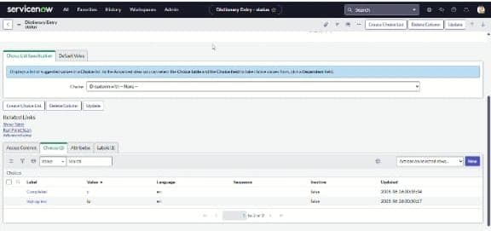**12. Click on choice and add to choices in the dictionary entry status**

**Milestone 2: import data**

**Steps**

**1. Open service now**

**2. Click on all > >search for system import s Select**

**3. Select load data and upload file that you have already created with four fields that are: (training name, completion date, status and employee)**

**4. Label: employee training**

**5. Name: u_employee_training**

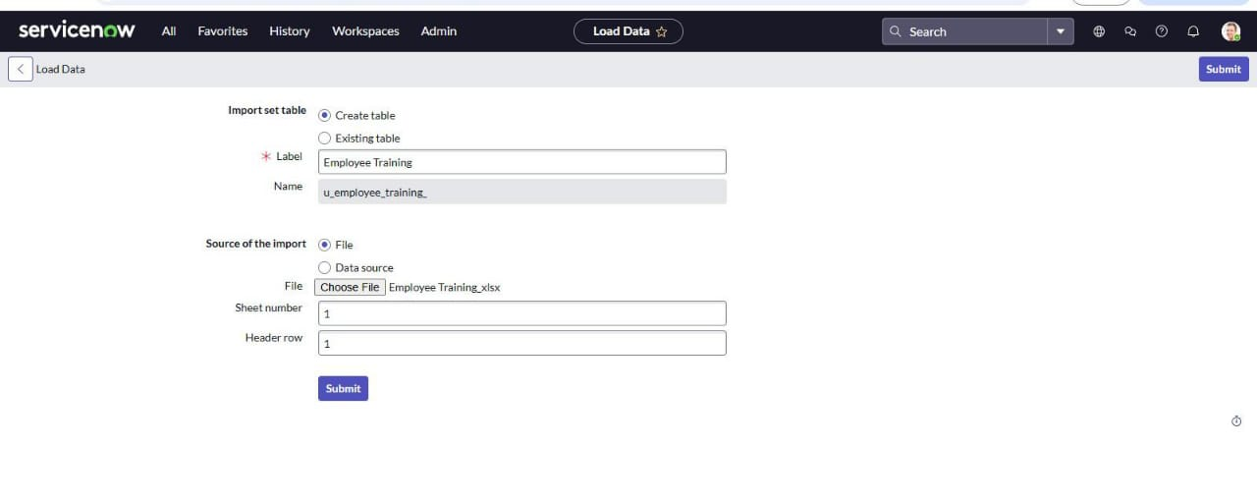

**6. Click to submit**

**MAP FIELDS:**

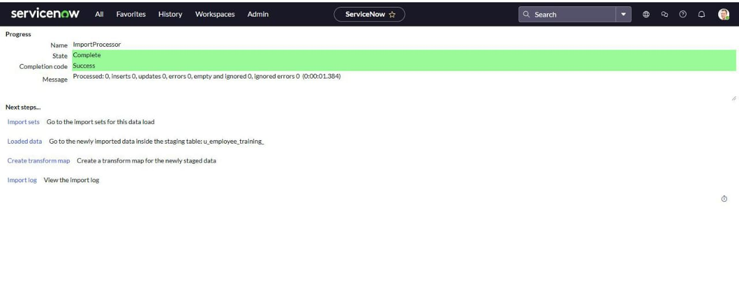

Steps:

1.Open service now

2.Click on all > > search for Transform maps

3.Fill the following details to create a new table

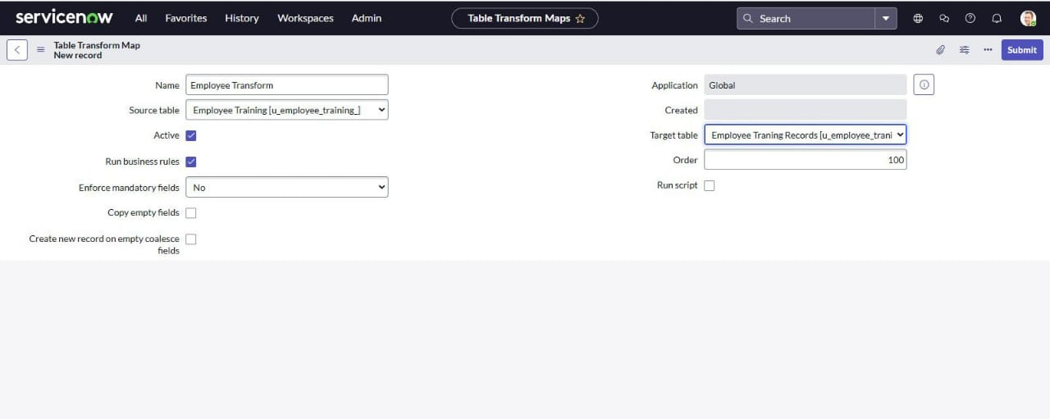

4. click on submit

5.add field maps as shown

6.click transform to run the import

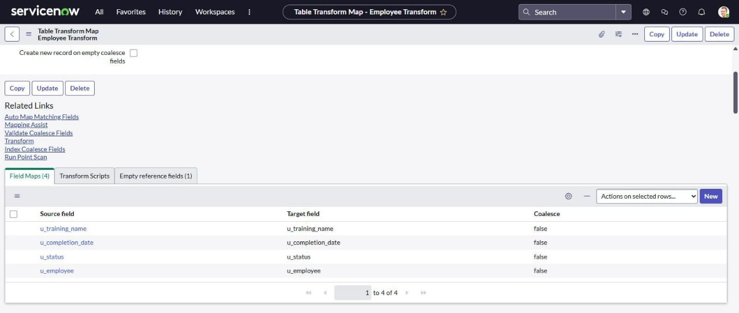

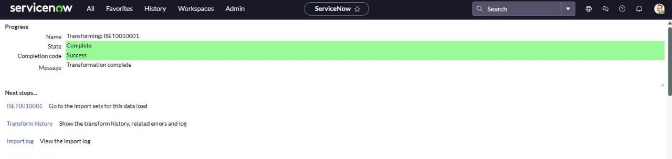7. Click transform to run the import

Milestone 3: using dot walking to access employee department information

Steps:

1.Open service now

2.Click on all >> system definition >>list layouts

3.Search for customer orders

4.Add the employee department field by using dot walking

5.Select the field and save changes

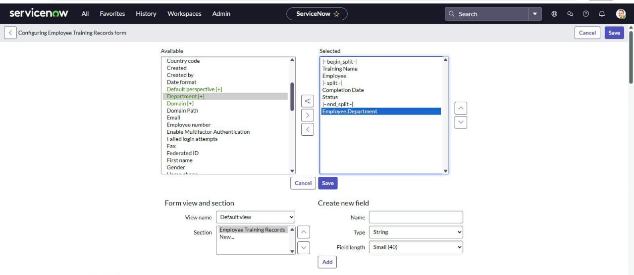 Milestone 4:Access control list (ACL)

Steps:

1.Open service now

2.Click on all>>ACL>>create new ACL

3.Define ACL (Employees)

4. Operation: Read

Milestone 5: Roles

Steps:

1.Open service now

2.Click on all>>roles>>create a new role:Hr manager

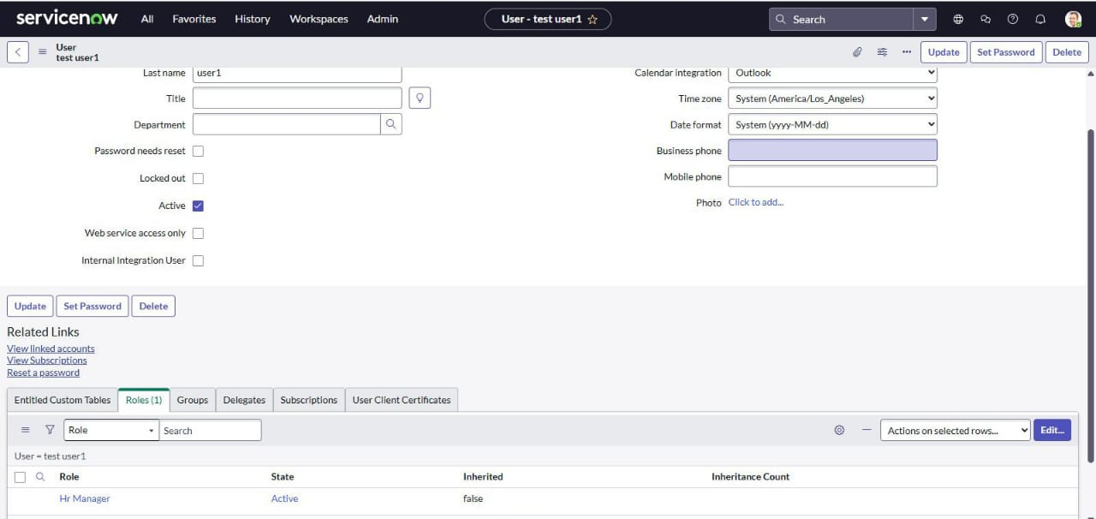3.Add in the sys_user

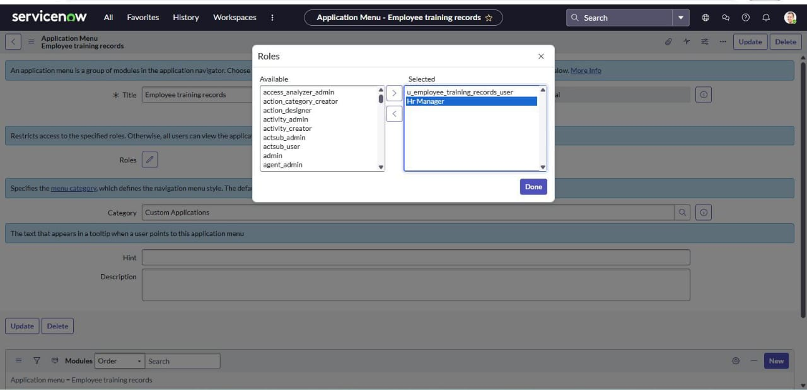4. Add this roll to the tables application and module

5. At the HR manager role to the sys_user

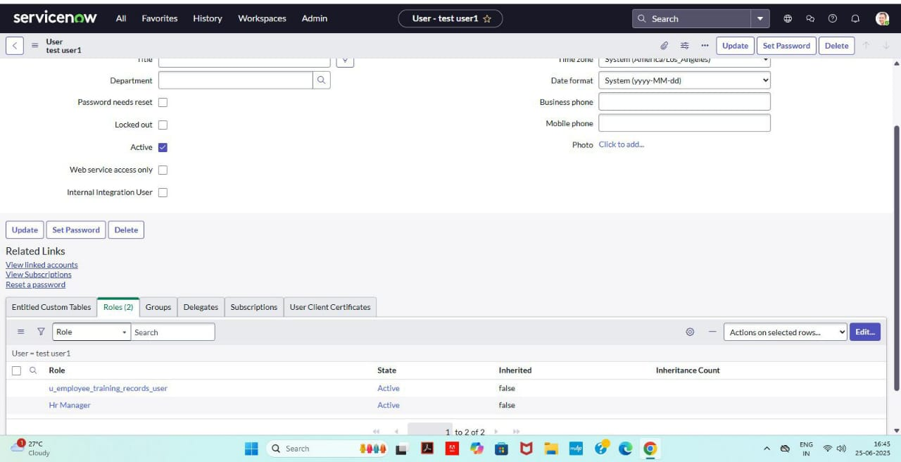

6. Now you can view each employees department information directly in the employee training records list view

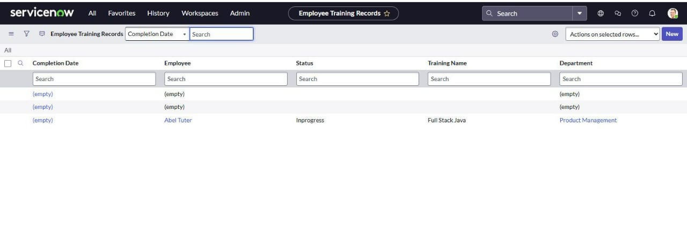

UPDATE TO ELEVATE ROLE :

Steps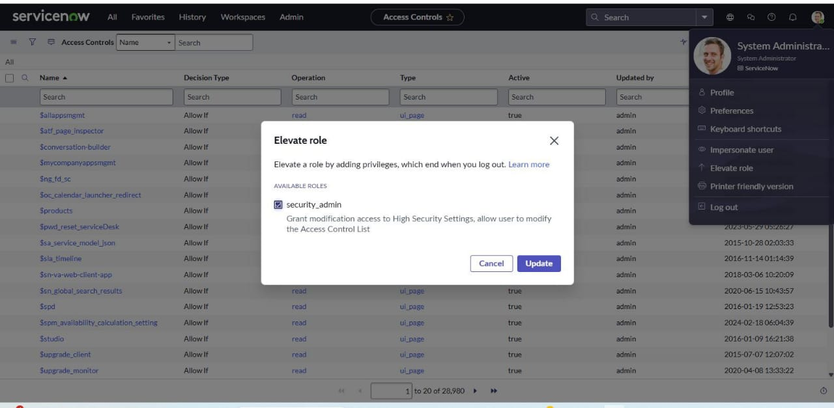 :

1. 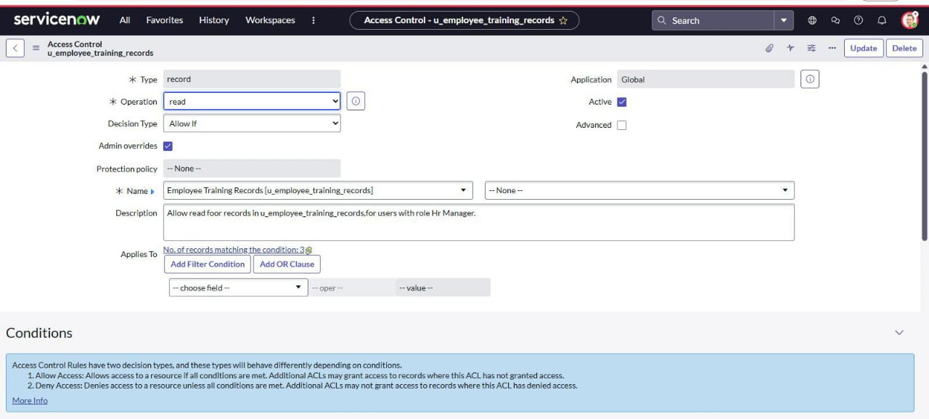Create new ACL and give read access to employee training record table
2. Give HR manager role to the ACL
3. Create another new ACL and repeat the same process to the write access

Milestone 6: result

Steps :

* 1. Impersonate the sys_ user and search employee training records
  2. 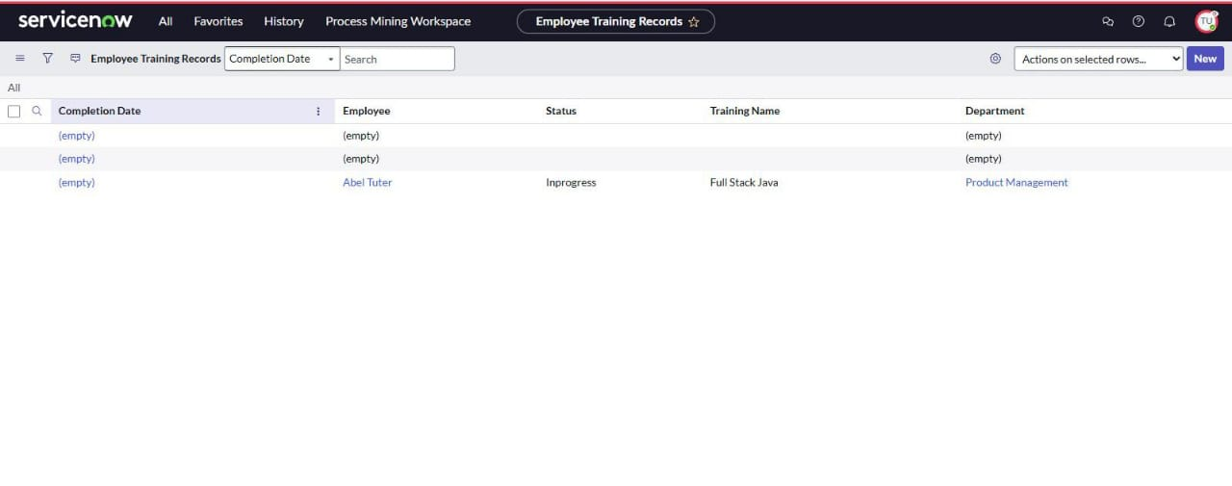Now you can see and edit the field

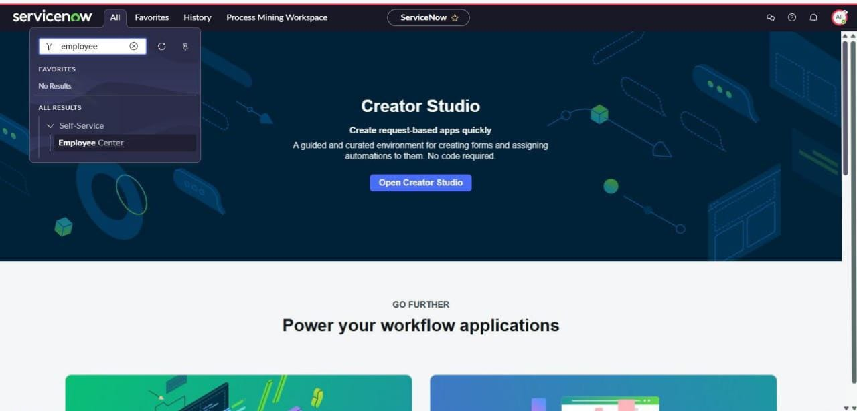3.Impersonate the other user you cannot see the table

PROJECT PLANNING AND SCHEDULING

Table. Create. Tables. 1 Pattika yulangasami

Import importing data. 1. Pattika yulangasami

Data

Import map. Fields. 1. Savara Geetha

Data

Using Dot Dot walking. 1. Savara. Geetha

Walking

Access

Employee

Department

Access control creating an ACL 1. Savara. Liyani

List

Roles. Create role. 1. Savara. Liyani

Roles. Update to elevant. 1. Savara Hemalatha

Result. Testing results 1. Savara Hemalatha

.

ADVANTAGES & DISADVANTAGES

Advantages

Ensures accurate data import and reduces errors.

Protects sensitive data from unauthorized access.

Helps meet regulatory requirements and industry standards.

Maintains data consistency and completeness.

Streamlines data import and management processes.

Minimizes risks associated with data breaches or unauthorized access.

Disadvantages

Importing and securing data can be a complex process, requiring specialized knowledge and expertise.

The process can be time-consuming, especially for large datasets or complex security configuration.

Importing and securing data may require significant resources, including personnel, infrastructure, and technology.

Errors during the import process can lead to data inconsistencies or security vulneraImplementing robust security measures and importing data can incur additional costs, such as licensing fees or consulting services.

CONCLUSION:

The importing and securing Data in service now project demonstrated the essential process of importing data into Service Now using Import Sets, leveraging dot-walking to access and utilize related table data efficiently, and applying Access Control Rules (ACLs) to enforce robust data security. By combining these core functionalities, we ensured accurate data integration, streamlined data relationships, and protected sensitive information through role-based access control.bilities.